**How to measure**

**Before Measuring, Choose Between Inside & Outside Mount**

**Inside Mount**

Clean, integrated look and the most popular choice. Window frame must accommodate the Required Minimum Depth for your desired window treatment. A common measuring mistake is not considering the depth needed when choosing Inside Mount. Depth determines which window treatment your window can accommodate with Inside Mount and how it will look when installed. To understand more about depth, see our blog.

**Outside Mount**

Makes windows appear larger and provides superior light control. (Chosen when Inside Mount is not an option because the window frame does not have enough depth for the window treatment).

**Inside Mount Shades**

**Step 1: Measure Width**

Measure inside the window frame horizontally in 3 places to the nearest 1/8 inch: top, middle & bottom. The shortest measurement = your width.

**Step 2: Measure Height**

Measure inside the window frame vertically in 3 places to the nearest 1/8 inch: left, middle & right.  
The longest measurement = your height.

**Step 3: Measure Depth**

Measure the inside depth to the nearest 1/8 inch at the top of the window frame. Be sur to consider any Window Obstacles. The shortest measurement = your depth.

**Outside Mount Shades**

**Step 1: Measure Width**

Measure horizontally to the nearest 1/8 inch between the outer-most points where you want your window treatments placed. For optimal light control, it's recommended to overlap each side of the window frame by at least an additional 3/4 inch.

**Step 2: Measure Height**

Measure vertically to the nearest 1/8 inch from the top of where you want the window treatment to be installed (headrail location) to the top of the windowsill, or measure to point of desired length if there is no sill.

**How to measure Patio Door**

Shades are mounted on the outside of the door frame.

**Width**

– Measure the exact width of the area to be covered.

– Add 4″ to the width. 2″ for each side as per drawing.

**Height**

– Measure the exact height of the area to be covered.

– Add 2″ to the height at the top and deduct 1/2″ at the bottom so the vanes are clear of the floor.

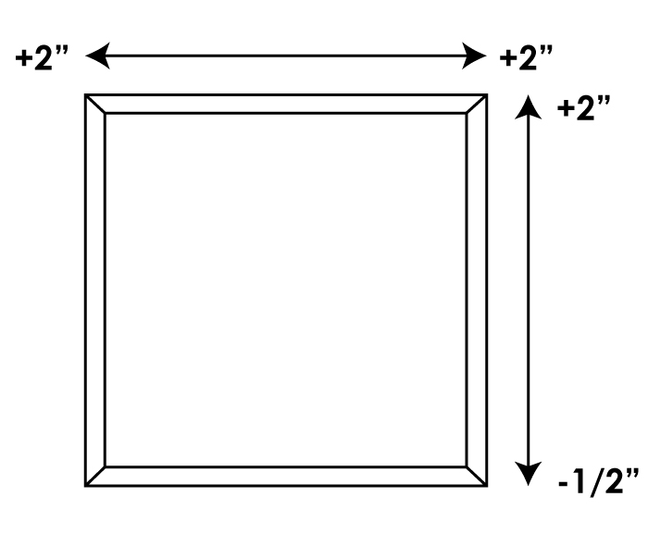

**Measuring Tips**

* Do not take deductions from your measurements.
* For Inside Mount, we will adjust to ensure a perfect fit.
* For Outside Mount installed outside of the window trim, you may need extension brackets or spacer blocks to account for the trim thickness.
* Measure each window – even ones that appear identical.
* All measurements should be to the nearest 1/8 inch.
* Use a metal tape measure as cloth ones may stretch.