Economy Digital AM/FM Tuner with USB
FTD-10T

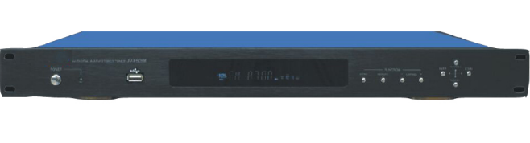
Description:

The FTD-10T is an AM/FM stereo digital tuner with USB that provides advanced technology and convenient use for a
public address background music source. It is built-in AM/FM digital stereo tuner, it also integrate Mp3 player with USB on front panel, the USB input with priority over tuner. With stereo RCA output, one selector to pre-set the output between mono or stereo. Simple and easy use audio sources player for commercial audio system and PA sound system.

Features:

Economy range digital stereo AM/FM tuner
19” rack mount type PA sound system audio source player
With IR remote control
Station memory stores up to 60 channels
Previous and next station selection
USB input on front panel
Mono audio output
With 19" rack mount bracket
Manual/automatic tuning
RCA audio output jacks
Frequency Response 20Hz – 20KHz
Freq range MW 522Kz-1620KHz
FM 87MHz-108MHz
DNR sensitivity MW 5Mv/m
AC power supply: 220V 50/60Hz
Dimensions 482*240*44mm

Weight: 2.3kg

Rear Panel:


