DVD player with MP3
FTD-200D
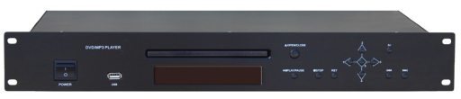

Description:

The FTD-200D is a 19” CD/DVD player with USB that provides advanced technology and convenient use for a public address background music source. It is built-in CD player, DVD player, it also integrate Mp3 player with USB on front panel. With stereo line input and video input by RCA and with stereo line output and video output by RCA. Simple and easy use audio source player for commercial audio system and PA sound system.
FEATURES:
l 19” rack mount type CD/DVD player with Mp3& USB
l Audio Source player for public address system & BGM
l Support various formats of CD/MP3/MP4/VCD/DVD player.
l With digital VFD display track and time.
l With IR wireless remote control to select source and volume control.
l Design with ESS decoding system of powerful error correction.
l With stereo line input and video input by RCA
l With stereo line output and video output by RCA
l After the POWER ON it will play in order automatically
l 1.5U height for rack installation audio sources player

Specifications:

Model | FTD-200D
Description | DVD Player with Mp3 Player & USB
Audio Input | 0.775V, 600  Ω
Video Output | 0.775V, 75  Ω
Frequency Response | 20-18KHz
THD | <60dB
S/N Ratio | >80dB
Power Consumption | 15W
Power Supply | AC110V or 220V, 50-60Hz
Dimension | 484(W)×365(D)×51(H)mm
Weight | 2.7kg

REAR PANEL:

