5" Wall Mount Speaker (3W/6W)
FWS-606
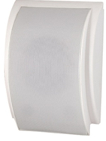
Feature:
- Commercial PA system wall mount speaker with transformer
- Ideal for school, office, hotel and airport background music system
- Rated power output 6W at 100V
- 5" full range paper driver unit
- Line input 100V or 70V
- ABS enclosure and metal grille in white
- Quick installation by screw hanging hole

Specification:
Model | FWS-606
Description | Wall Mount Speaker
Rated Power Output | 3W/6W
Line Input | 100V or 70V
Frequency Response | 130-15KHz
SPL(@1W/m) | 92dB
Speaker Unit | 5” full range paper cone
Dimension | 312(W)×210(D)×85(H)mm
Net Weight | 1.7kg
Material | ABS enclosure and metal grille in white
Mounting Way | Quick installation by screw hanging hole
Gross Weight | 17kg

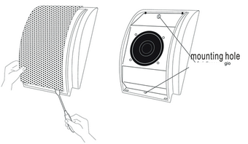
Dimension & Mounting:

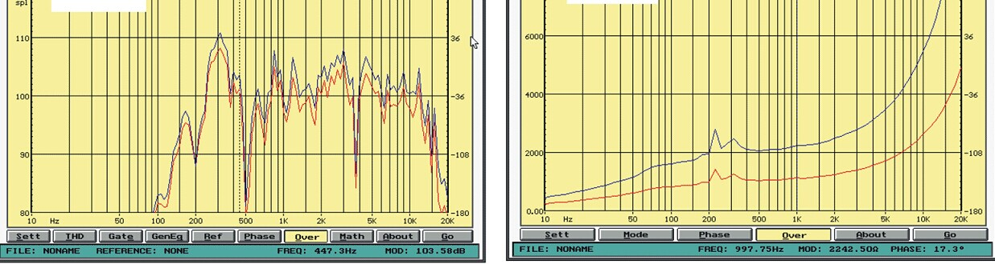
Frequency Response & SPL Diagrams:

