IP POE Powered Wall Mount Speaker
FIP-920POE
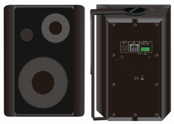

Description:

The IP POE Powered Wall Mount Speaker is the latest in IP technology. This Power over Ethernet (Compatible with both IEEE 802.3af & IEEE 802.3at) VoIP mass notification device has network-controlled speaker volume, scheduled program broadcast, priority-based multicast streaming, group definition, working status supervision, remote online technical support and trouble shoot. The speaker is capable of broadcasting audio through multicast.

The POE powered wall mount speaker enable to be built up an IP based sound system through a single CAT5 or CAT6 wire. The single CAT5 cable is used for control data, signal data and power supply, by this way, the layout cost will be much decreased without any consideration of AC nor DC power supply.

The POE powered ceiling speaker is compatible with universal POE switch, thus the POE speaker works with existing POE LAN/WAN & internet network and fiber-optical cable, no need dedicated network to be built-up. So it is very useful for office, hotel, school, bank, factory & shopping mall where POE network is already there. External DC12V connector is also equipped in this POE speaker for standby power supply use.

The POE ceiling speaker is designed with 5” two way wall mount speaker with 15W class-D amplifier.

There is one contact input and one contact output to interactive with third party system. The remote paging microphone IP-600RM enables to make announcement over individual speaker, group speakers over network.

Features:
- POE (Power over Ethernet) supportable all in one network audio system
- POE IP PA system with background music, paging system and voice alarm system
- Minimum cable connection over existing LAN/WAN/Internet system
- Huge system capacity up to 1,200 zones
- Support with existing POE switch network system
- Compatible with both IEEE 802.3af & IEEE 802.3at
- IP based POE powered 15W 5” two way wall mount speaker
- Built-in IP module, 15W class-D amplifier and speaker
- Single network cable for control, signal and power supply
- Same POE speakers enable to be several group or zone defined
- Different music or voice message simultaneously broadcasted through different POE speakers
- Paging prioritization and background music system
- Network adjustable speaker volume
- Closed contact input & Closed contact output for third party integration
- DC12V power supply input as standby use
IP POE Powered Wall Mount Speaker
FIP-920POE

Side View & Dimensions:
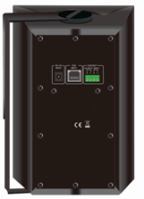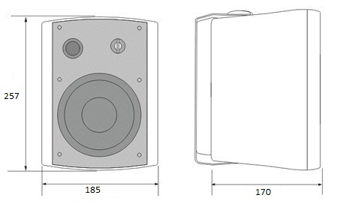

Specifications:
Model | FIP-920POE
Description | IP POE Wall Mount Speaker
Power Output (1KHz@-3dB) | 10 Watts/15W Watts
Built-in Amplifier | 15W Watts
Speaker Unit | 5” woofer+1.5” tweeter
Network I/F | 10/100Mbps
Protocol | ARP, TCP/IP, UDP, ICMP & IGMP (Group Broadcast)
Audio Format | MP3/MP2
Audio Quality | 16digit stereo CD level
Sampling Rate | 8K~48K
Bit Rate | 8K~512Kbps
Sensitivity | 92dB/1W/1M
S/N Ratio | ≧85dB
THD | ≦0.1%
Frequency Response | 100-18KHz（±3dB）
Connector | One RJ45 port for existing LAN/WAN & internet  One control input, 0V, short circuit contact  One control output, 0V, short circuit contact  One DC12V battery backup input
Power Input | POE 802.3af or POE 802.3at & DC 12V
Operation Temp | -30℃ to +55℃
Dimension | 257(W)×185(D)×170(H)mm
Bracket | U-Shaped wall mount bracket
Material | ABS cabinet and steel grille
Weight | 2.5kg

