Zone Voice Alarm Remote Microphone
EN-6500TM
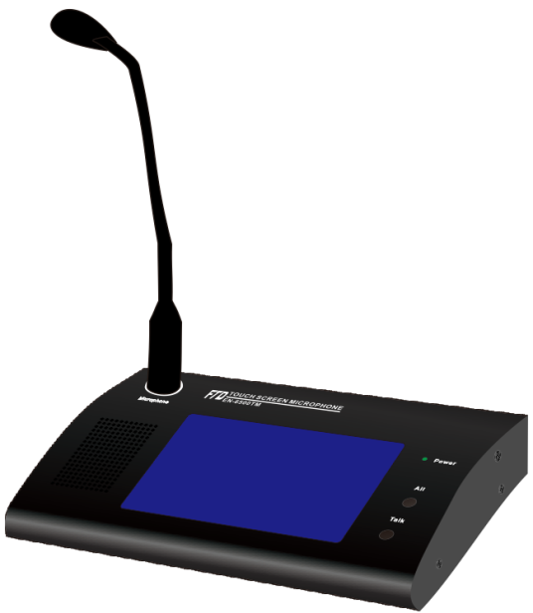
Features:
- Digital voice evacuation system remote paging microphone.
- Each microphone of 120 zone capacity.
- Support 32 remote microphones of loop connection.
- Remote paging microphone with touch screen display.
- System indicators of AC, DC, fault, Mic status and test.
- 120 zone selection buttons through touch screen and all zone/talk button.
- Two RJ45 ports for connection with EVAC-500 and next remote microphone.
- One 3.5mm line input, with output volume control.
- Support PPT and normal paging two modes.
- DC24V power supply or POE.
- Support loop connection and paging microphone failure has been supervised.
- With free software to monitor the microphone working status and fault.

Specifications:

Model | EN-6500TM
Description | Voice Alarm Remote Microphone (Touch Screen)
Power Consumption | 3W
Zone Capacity | 120 Zones
System Capacity | 32 Remote microphones
Line Inputs | 350mV, 10kΩ
Mic Input | 5mV, 600Ω
Frequency Response | 80Hz~16kHz
THD | ＜1% at RMS,1KHz
S/N Ratio | >70dB
Operating Temp | -20℃ to +70℃
Power Supply | DC24V, ±20%
Humidity | <95% no condensation
Dimension | 256(W)×149(H)×52(D) mm
Weight | 1.5kg
Rear Panel:

