Zone Voice Alarm Remote Microphone
EN-6500RM
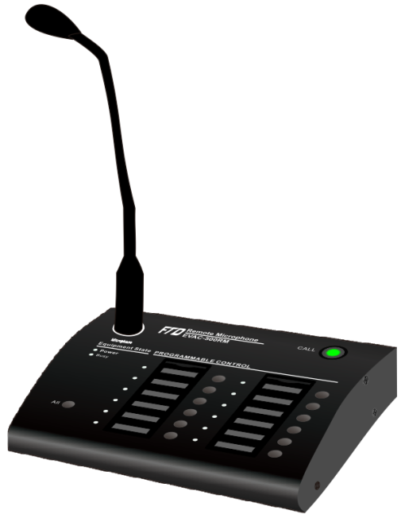
Features:
- Digital voice evacuation system remote paging microphone.
- Each microphone of 12 zone capacity.
- System support 32 remote microphones of loop connection.
- System indicators of AC, DC, fault, Mic status and test.
- 12 zone selection buttons and all zone button.
- 12 zone selection buttons can be programmed.
- Two RJ45 ports for connection with EN-6500 and next remote microphone.
- One 3.5mm line input, with output volume control.
- Support PPT and normal paging two modes.
- CAT5 or CAT6 cable communication up to 600 meters.
- DC24V power supply from EVAC-500 controller.
- Support loop connection and paging microphone failure has been supervised.

Specifications:

Model | EN-6500RM
Description | Voice Alarm Remote Microphone
Power Consumption | 3W
Zone Capacity | 12 Zones
System Capacity | 32 Remote microphones
Line Inputs | 350mV, 10kΩ
Mic Input | 5mV, 600Ω
Frequency Response | 80Hz~16kHz
THD | ＜1% at RMS,1KHz
S/N Ratio | >70dB
Operating Temp | -20℃ to +70℃
Power Supply | DC24V, ±20%
Humidity | <95% no condensation
Dimension | 256(W)×149(H)×52(D) mm
Weight | 1.5kg
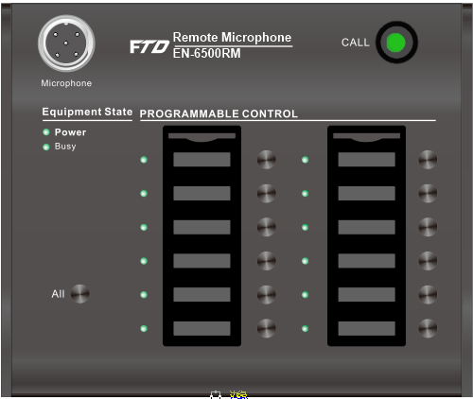
Rear Panel:
