Zone Voice Alarm Remote Microphone
EN-6500FM

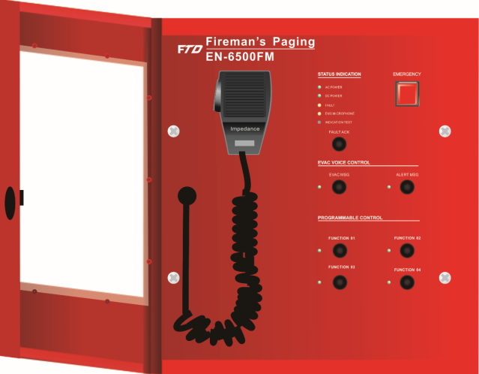
Features:
- Fireman microphone meet the EN54 standard.
- Four programmable keys and EVAC/Alert.
- Remote pre-recorded message broadcast in case of emergency.
- Remote fireman microphone highest priority announcement in case of emergency.
- Emergency microphone signal path real-time monitoring.
- Different levels of priority configurable.
- Support DC 24V phantom power supply from the controller.
- With AC, DC, fault, MIC and indication test four indicators.
- With emergency activation button for all zone EVAC operation.
- Communication distance up to 600 meters.
- Communication with controller through CAT6 cable.
- Each system supports 32 units of fireman microphone maximum.
- Support normal paging mode and PTT modes.
- With DIP switch to set its ID on rear panel.
- Support line redundancy connection.
- With lock and key to ensure access permission.
- IP55 outdoor operation support.

Specifications:

Model | EN-6500FM
Description | Fireman Microphone
Power Consumption | 3W
System Capacity | 32 units
Frequency Response | 80Hz~16kHz
THD | ＜1% at RMS,1KHz
S/N Ratio | >70dB
SPL | 30mV
Power Supply | Phantom power 20V ~ 27.5V, ±20%
IP Rate | IP55
Operating Temp/Humidity | -20℃ to +50℃; <95% no condensation
Finish | Stainless steel in red and ABS cover
Dimension & Weight | 298(W)×298(D)×89(H) mm; 3.8kg

