5" Fireproof Wall Mount Speaker (3W-6W)
FFS-406
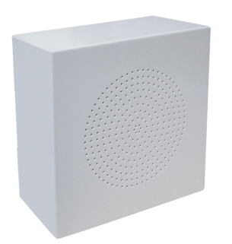
Feature:
- Commercial fireproof wall mount speaker with transformer
- Ideal for school, office, hotel and airport voice evacuation and PA system
- Compliant with the EN54-24 EVAC standard
- Ceramic connector, fire dome, 95℃ fire-resistant cable and thermal fuse
- Rated power output 3W-6W at 100V
- 5" full range paper non-flammable driver unit
- Line input 100V or 70V with transformer
- Steel enclosure, steel grille and fire dome in white RAL7035
- Wall mount or surface mount quick installation by screw hole

Specification:
Model | FFS-406
Description | Fireproof Wall Mount Speaker
Rated Power Output | 3W-6W
Line Input | 100V or 70V
Frequency Response | 120-10KHz
SPL(@1W/m) | 92dB
Speaker Unit | 5” full range paper non-flammable driver unit
Dimension | 160(W)×160(D)×60(H)mm
Material | Steel enclosure, steel grille and fire dome in white RAL7035
Mounting Way | Quick installation by hanging screw hole
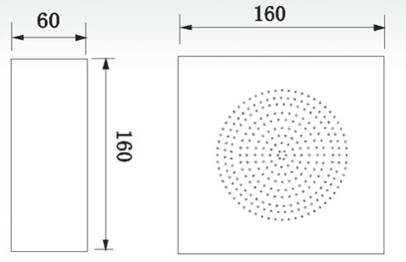
Mounting, Dimension & Side View:

Frequency Response & SPL Diagram:
